PROJECT 4

Git Project:

Task 1: - Create a repository in GitHub.

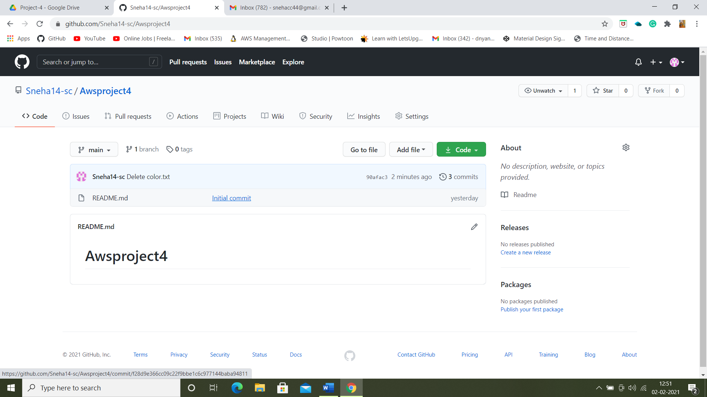

* Create a folder in C-Drive:

Task 2: - Open a git bash in the folder named ‘Project4git’.

* Git init
* Both config commands
* Showing the folder in local repository

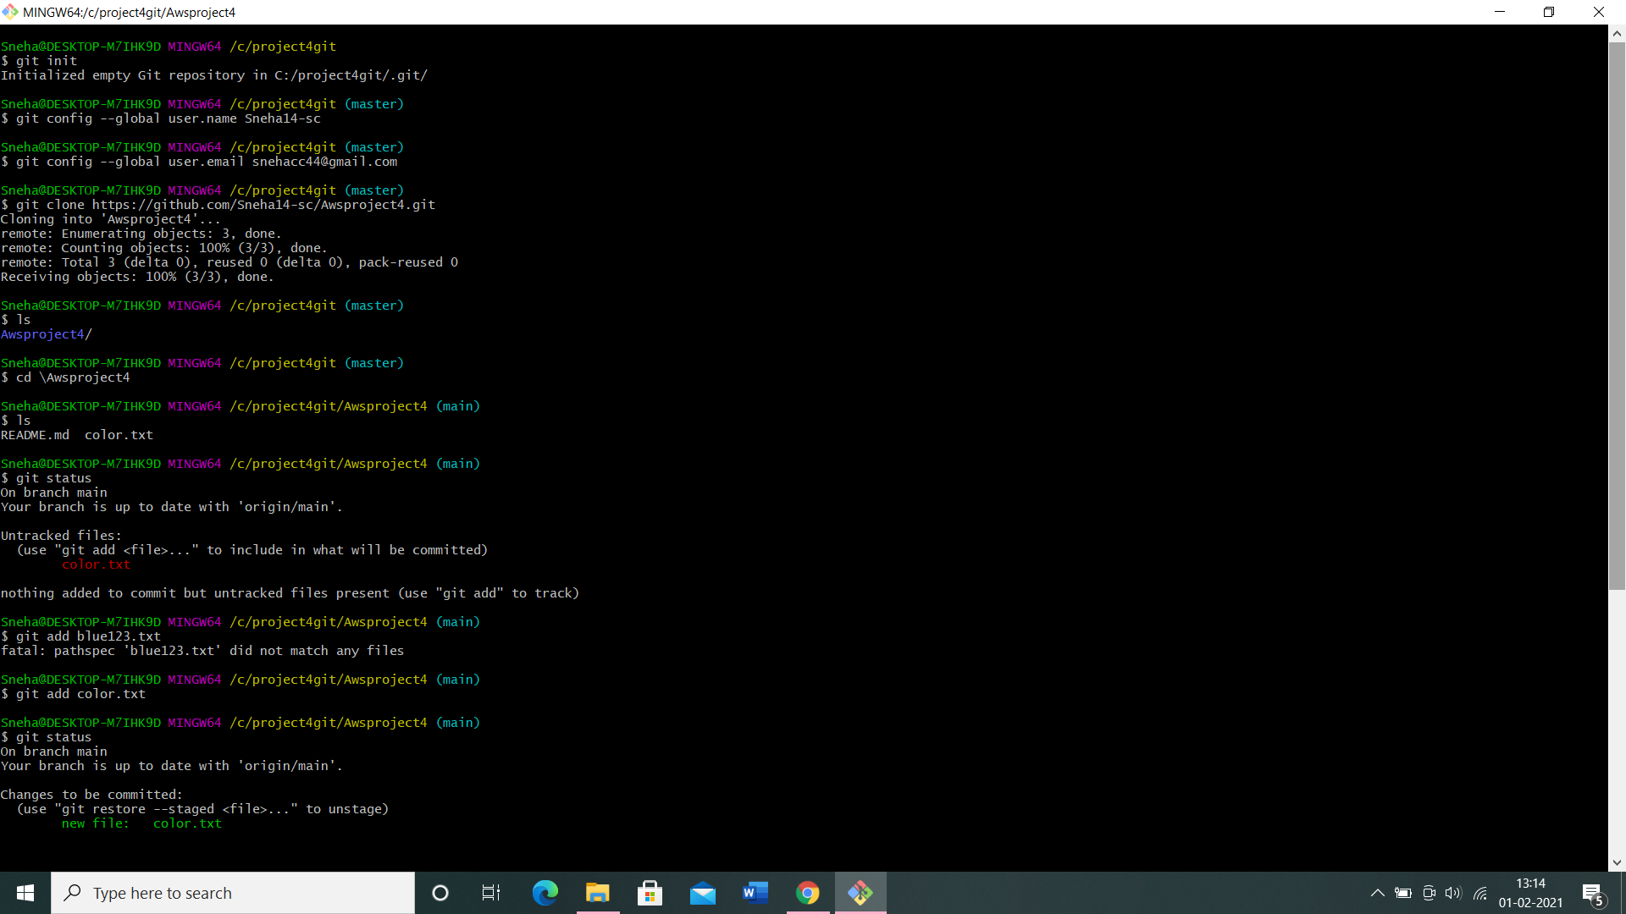

Task 3: - Create a file in the local space and push it to the remote repository.

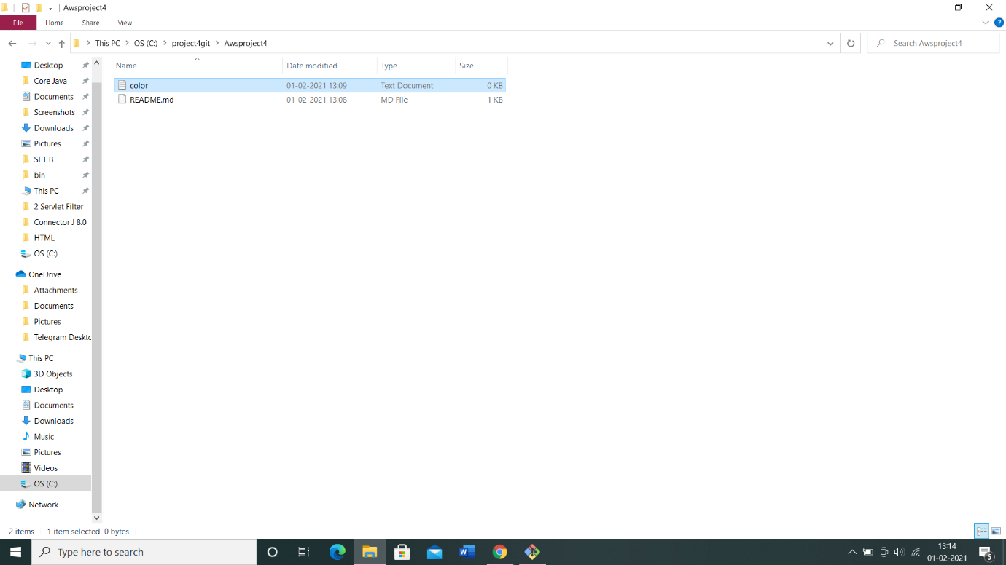

* Add
* Commit
* Push successful
* Show the file in remote repository



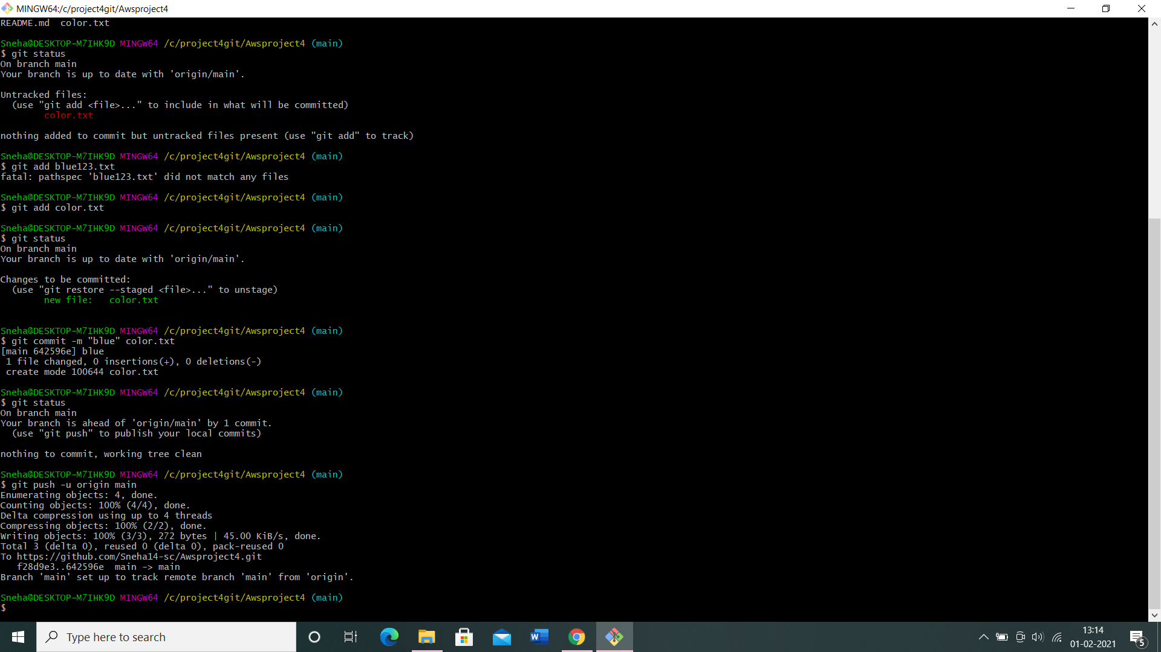

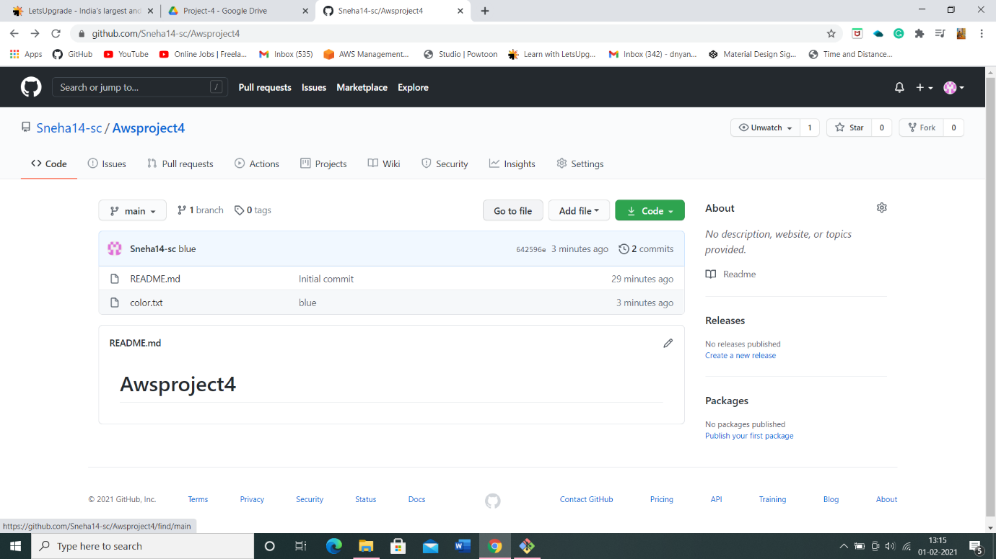

Task 4: - Branching and merging.

Git branching:

● git branch

● git branch branchname

● git checkout branchname

● git merge branchname

● git branch -d branchname

● git branch -D branchname

● git checkout -b branchname

● git log

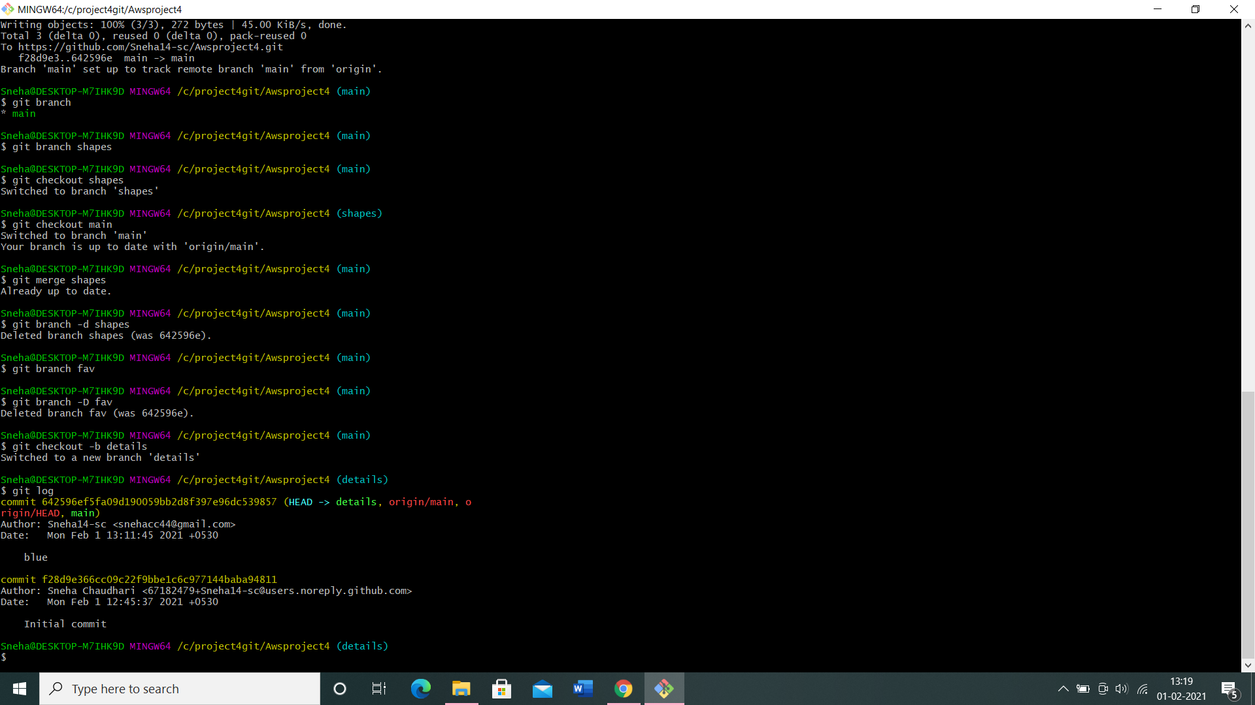

**The End**